27.91: a) The maximum speed occurs at the top of the cycloidal path, and hence the radius of curvature is greatest there. Once the motion is beyond the top, the particle is being slowed by the electric field. As it returns to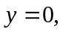 the speed decreases, leading to a smaller magnetic force, until the particle stops completely. Then the electric field again provides the acceleration in the y-direction of the particle, leading to the repeated motion.
b) 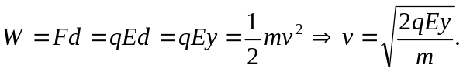
c) At the top,
